Race conditions
Race conditions are a common type of vulnerability closely related to business logic flaws. They occur when websites process requests concurrently without adequate safeguards. This can lead to multiple distinct threads interacting with the same data at the same time, resulting in a "collision" that causes unintended behavior in the application. A race condition attack uses carefully timed requests to cause intentional collisions and exploit this unintended behavior for malicious purposes.
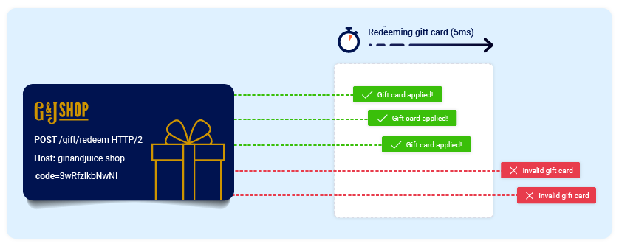
The period of time during which a collision is possible is known as the "race window". This could be the fraction of a second between two interactions with the database, for example.
Like other logic flaws, the impact of a race condition is heavily dependent on the application and the specific functionality in which it occurs.
In this section, you'll learn how to identify and exploit different types of race condition. We'll teach you how Burp Suite's built-in tooling can help you to overcome the challenges of performing classic attacks, plus a tried and tested methodology that enables you to detect novel classes of race condition in hidden multi-step processes. These go far beyond the limit overruns that you may be familiar with already.

PortSwigger Research
As usual, we've also provided a number of deliberately vulnerable labs that you can use to practice what you've learned safely against realistic targets. Many of these are based on original PortSwigger research, first presented at Black Hat USA 2023.
For more details, check out the accompanying whitepaper: Smashing the state machine: The true potential of web race conditions

Limit overrun race conditions
The most well-known type of race condition enables you to exceed some kind of limit imposed by the business logic of the application.
For example, consider an online store that lets you enter a promotional code during checkout to get a one-time discount on your order. To apply this discount, the application may perform the following high-level steps:
- Check that you haven't already used this code.
- Apply the discount to the order total.
- Update the record in the database to reflect the fact that you've now used this code.
If you later attempt to reuse this code, the initial checks performed at the start of the process should prevent you from doing this:
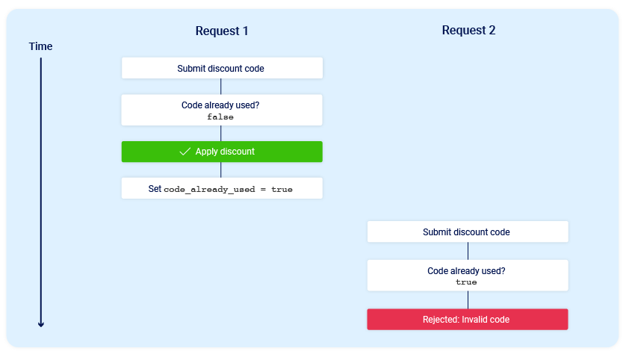
Now consider what would happen if a user who has never applied this discount code before tried to apply it twice at almost exactly the same time:
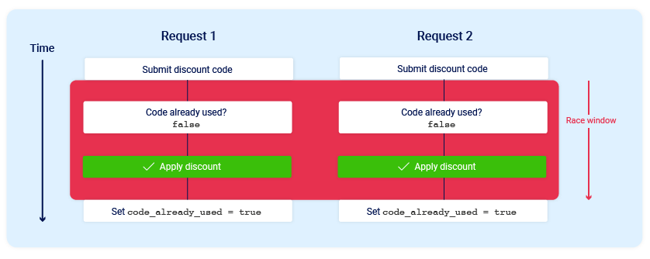
As you can see, the application transitions through a temporary sub-state; that is, a state that it enters and then exits again before request processing is complete. In this case, the sub-state begins when the server starts processing the first request, and ends when it updates the database to indicate that you've already used this code. This introduces a small race window during which you can repeatedly claim the discount as many times as you like.
There are many variations of this kind of attack, including:
- Redeeming a gift card multiple times
- Rating a product multiple times
- Withdrawing or transferring cash in excess of your account balance
- Reusing a single CAPTCHA solution
- Bypassing an anti-brute-force rate limit
Limit overruns are a subtype of so-called "time-of-check to time-of-use" (TOCTOU) flaws. Later in this topic, we'll look at some examples of race condition vulnerabilities that don't fall into either of these categories.

Detecting and exploiting limit overrun race conditions with Burp Repeater
The process of detecting and exploiting limit overrun race conditions is relatively simple. In high-level terms, all you need to do is:
- Identify a single-use or rate-limited endpoint that has some kind of security impact or other useful purpose.
- Issue multiple requests to this endpoint in quick succession to see if you can overrun this limit.
The primary challenge is timing the requests so that at least two race windows line up, causing a collision. This window is often just milliseconds and can be even shorter.
Even if you send all of the requests at exactly the same time, in practice there are various uncontrollable and unpredictable external factors that affect when the server processes each request and in which order.
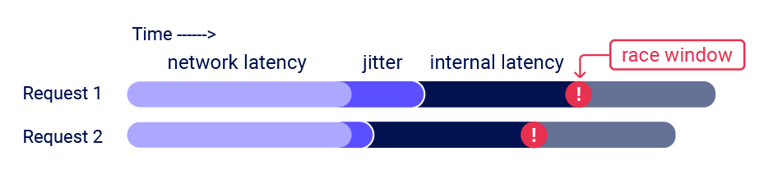
Burp Suite 2023.9 adds powerful new capabilities to Burp Repeater that enable you to easily send a group of parallel requests in a way that greatly reduces the impact of one of these factors, namely network jitter. Burp automatically adjusts the technique it uses to suit the HTTP version supported by the server:
- For HTTP/1, it uses the classic last-byte synchronization technique.
- For HTTP/2, it uses the single-packet attack technique, first demonstrated by PortSwigger Research at Black Hat USA 2023.
The single-packet attack enables you to completely neutralize interference from network jitter by using a single TCP packet to complete 20-30 requests simultaneously.
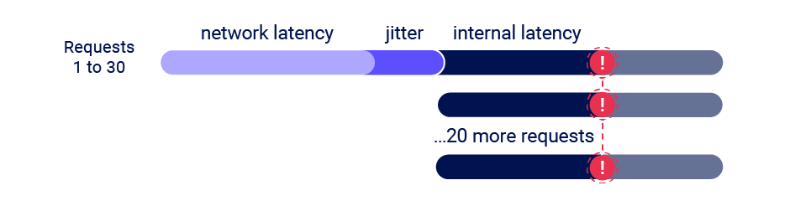
Although you can often use just two requests to trigger an exploit, sending a large number of requests like this helps to mitigate internal latency, also known as server-side jitter. This is especially useful during the initial discovery phase. We'll cover this methodology in more detail.

Read more
- For details on how to use the new features of Burp Repeater to send multiple requests in parallel, see Sending requests in parallel.
- For a technical insight into the underlying mechanics of the single-packet attack, and a more detailed look at the methodology, check out the accompanying whitepaper: Smashing the state machine: The true potential of web race conditions

Detecting and exploiting limit overrun race conditions with Turbo Intruder
In addition to providing native support for the single-packet attack in Burp Repeater, we've also enhanced the Turbo Intruder extension to support this technique. You can download the latest version from the BApp Store.
Turbo Intruder requires some proficiency in Python, but is suited to more complex attacks, such as ones that require multiple retries, staggered request timing, or an extremely large number of requests.
To use the single-packet attack in Turbo Intruder:
- Ensure that the target supports HTTP/2. The single-packet attack is incompatible with HTTP/1.
- Set the engine=Engine.BURP2 and concurrentConnections=1 configuration options for the request engine.
- When queueing your requests, group them by assigning them to a named gate using the gate argument for the engine.queue() method.
- To send all of the requests in a given group, open the respective gate with the engine.openGate() method.
def queueRequests(target, wordlists): engine = RequestEngine(endpoint=target.endpoint, concurrentConnections=1, engine=Engine.BURP2 ) # queue 20 requests in gate '1' for i in range(20): engine.queue(target.req, gate='1') # send all requests in gate '1' in parallel engine.openGate('1')
For more details, see the race-single-packet-attack.py template provided in Turbo Intruder's default examples directory.

